CELL CITY
Now it’s your turn…
•To show me what you know using what you’ve learned and some creativity.
•You will create an analogy of your own.
•Due at the end of the period.
YOU MAY NOT USE A CITY FOR YOUR METAPHOR

Cell City
What is required
•Color illustration of your Cell Metaphor
•The following organelles must be included :Nucleus, nuclear membrane, ribosome, endoplasmic reticulum, mitochondria, lysosomes, golgi complex, vacuole, cytoskeleton.
•A key explaining how each part of your city corresponds to the actual parts of the cell.
•Be imaginative. This is a chance for you to be as creative as you like.
•You will be graded mainly on how well you represent the parts of the cell, but some of your grade will depend on originality and apparent effort on the work.

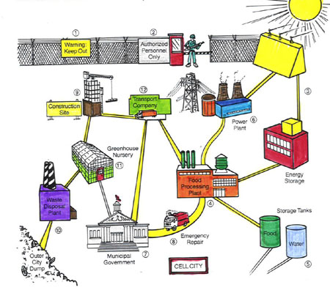

How Metaphor Function
Metaphor Structure
2 Important Details
Major Function
Cell Organelle

